2016:
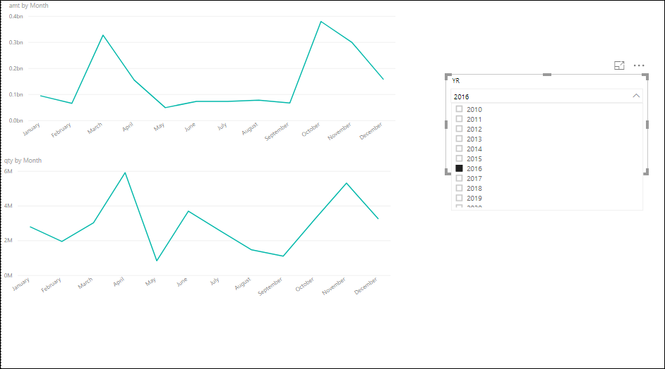
In this year, the highest amount of purchases is in the month of March and October, where the highest value is around 0.4bn in October. Whereas, the quantity acquired is the most in April and November with a value of 6M in November.
2017:
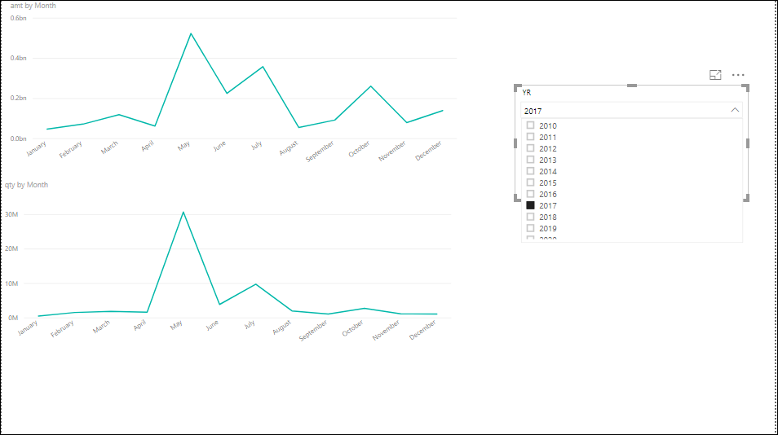
In this year, the purchasing of raw material declined, where the highest amount is somewhere near 0.7bn. As far as the quantity is concerned, it was more than 30M in May.

2018:
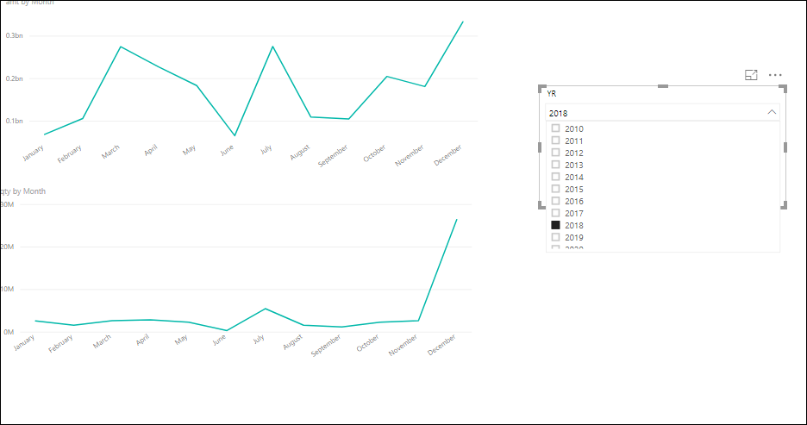
In this year, the highest amount spent is 0.47bn in December, whereas due to high purchasing, the amount keeps fluctuating in March, July and December. As for the quantity, it remained low and steady, except in December, whereas we see the most raw materials ordered as 30M.

